Home Page

What is QUICKAID?
QUICKAID addresses the inefficiencies of the traditional, manual AICS application process by providing a secure and user-friendly digital platform. Applicants can submit their requests for medical, educational or burial assistance through our web application management system, while social workers and administrative personnel can manage and evaluate these applications more efficiently through an integrated backend system. The system incorporates automated centralized storage, application history tracking, and data visualization tools to support decision-making and service delivery. By incorporating PostgreSQL as its database system and implementing ISO/IEC 25010:2017 software quality standards, QUICKAID ensures accuracy, data integrity, and performance reliability.

Mission & Vision

Mission
QUICKAID aims to empower communities in crisis by delivering a fast, transparent, and accessible digital platform for government aid application and management. Through innovation and automation, it seeks to reduce processing time, eliminate redundant tasks, and improve the quality of public service delivery.

Vision
To become a pioneering digital solution in public welfare service management enabling government programs like AICS to operate with integrity, efficiency, and compassion while promoting data-driven decision-making for inclusive and resilient communities.

About Us Page
-AICS Definition

Privacy Notes:

PRIVACY NOTICE
I. SERVICE DESCRIPTION
The Program Management Bureau (PMB) ensures the responsive and efficient implementation of social welfare and development (SWD) programs, projects, and services for the vulnerable and marginalized sectors of society. It shall implement programs prescribed by laws, particularly those concerning SWD sectors, e.g. children, youth, women, senior citizens, and persons with disabilities.
While carrying out our mandate, we are committed to protecting the privacy, confidentiality, and security of personal data of individuals or families who have requested the Bureau’s assistance, in accordance with the Data Privacy Act (DPA) of 2012 and its Implementing Rules and Regulations (IRR), as well as other directives as required by the National Privacy Commission and all other applicable laws.
This Privacy Notice explains how the PMB, as a Personal Information Controller, will deal with you as its clients in protecting your personal data. It answers what information is collected from you, how and why these are collected, stored, used, retained, disclosed and shared, and disposed, and how you can exercise your privacy rights as data subject.
Please read this thoroughly.
II. PERSONAL DATA THAT WE MAY COLLECT
The personal data we collect from you or from your authorized representative are the following, but not limited to:
Personal Information: name, address, job position, monthly salary or income, source of income, type of employment, contact information such as landline or mobile number and email address, gender, birth date, citizenship (for persons of concerns), beneficiary category, family composition, benefits information, images recorded through our systems or CCTV.
III. COLLECTION METHOD
We collect your personal data by submitting application forms, whether written or electronic, or in any other similar manner, for any business dealings or services you may request from PMB. Your images may also be recorded in premises equipped with a CCTV monitoring system or via the cameras installed in our existing program systems.
We will collect your personal data under the following conditions:
a) With your expressed consent, unless applicable laws and regulations do not require us to do so; and
Without your expressed consent, there will be no processing of your personal data. You can also withhold or withdraw consent and personal data previously given. However, we may not be able to process your requested service from us.
b) Only necessary, adequate, relevant information for the processing of your requested service and/or transaction.
If you believe that your personal data is being collected in an excessive and unjustifiable manner, please notify the Data Privacy Office of the DSWD immediately.
IV. TIMING OF COLLECTION
We collect personal data when you submit application forms, whether written or electronic, or in any other similar manner, for any business dealings or services you may request from PMB. Your images may also be recorded if you are present in a building with a CCTV monitoring system or a camera from one of our existing program systems.
V. PURPOSE OF COLLECTED PERSONAL DATA
Your personal data collected will be used to process your requested service and/or transaction with PMB or other legitimate purpose, such as but not limited to the following:
a) Internal Customers (PMB Directors, Officers, Employees and personnel and their dependents): for employment-related services, benefits and compliance to government worker requirements.
b) External Customers: clients/beneficiaries seeking assistance, applications for employment to PMB, supplier/service provider partnership;
If you are one of our valued clients or partners, your personal data will be managed and used for processing purposes such as membership; partnership; or release of assistance; surveys to improve service delivery, and other purposes such as security and surveillance and responding to complaints.
c) Mandatory to protect your vitally important interests as our clients including life and health;
d) Purpose in pursuit of PMB’s interests and mandates as per Administrative Order No. 1 series of 2019 entitled Management Reorganization of the DSWD Central Office, and authorized entities to whom the data may be disclosed in accordance with PMB’s legal, contractual, and regulatory obligations; and
e) To respond to any legal procedure, national interest such as an emergency, or compliance with public order and safety, to fulfill a constitutional or statutory mandate of a public authority, such as but not limited to: Congress inquiry, and government agencies, including law enforcement agencies and courts of law;
By default, our policy prohibits the collection and processing of sensitive personal information and privileged information, unless such information is required for the processing of your requested service and/or transaction with the PMB.
If you believe that providing sensitive personal information is unnecessary, you have the right to object or refuse to do so. Please notify the Data Privacy Office as soon as possible.
Furthermore, we do not sell your personal information to any third party.
VI. STORAGE AND TRANSMISSION OF PERSONAL DATA
Your personal data collected by written, electronic, or recorded means shall be stored, controlled, and monitored by the PMB or Personal Information Processors where the specific personal data processing system is used in the collection of your personal data. The importance of shared responsibility among all personnel of each program shall be recognized in terms of ensuring the protection of the personal data collected by the PMB.
The PMB shall secure the collected personal data by implementing security measures such as ensuring that files containing Personal Information and/or Sensitive Personal Information, undergo encryption in adherence to strict password complexity best practices accessible only to authorized personnel. Additionally, a systematic removal process is implemented for these files after use, minimizing the risk of unauthorized access. Moreover, access to online repositories containing such sensitive information is strictly restricted to authorized individuals.
Personal data transmitted to the Information and Communication Technology Management Service (ICTMS) must be electronically processed and stored in firewall-protected databases.
In order to protect your personal data at rest and in transit against loss, misuse, modification, unauthorized or accidental access or disclosure, alteration, or destruction, we will use appropriate privacy safeguards such as organizational, physical, and technical security measures.
Any data security incident or breach that comes to our attention must be documented and reported in accordance with the law. We will take all reasonable steps to address such incidents or breach and mitigate any negative consequences. If there is a strong suspicion that an incident has affected your personal data, we will notify you in a timely and appropriate manner.
VII. METHOD OF USE
All personal data collected from you will be used to process your requested service, assistance, or transaction with PMB, as well as for other legitimate purposes that do not violate the Data Privacy Act, its Implementing Rules and Regulations, or other applicable laws.
Only trained, competent and authorized personnel such as social workers, information technology officers and selected social development workers will have access to and process your personal data. To protect your privacy, confidentiality, and security, any disclosure or sharing is subject to organizational or internal controls and policies.
Physical and electronic records containing your personal data must be stored securely for future use and disposed of when no longer required or in accordance with organizational policies and other laws governing records management.
VIII. LOCATION OF PERSONAL DATA
Your personal data transmitted by PMB to Information and Communication Technology Management Service (ICTMS) for processing and storage are located in the servers being maintained by the DSWD. The Department is located at the Batasan Pambansa (BP) Complex, Constitution Hills, Quezon City.
PMB does not store or transmit your personal data to any entity outside the country.
IX. THIRD PARTY TRANSFER
Your collected personal data will only be accessed and used by authorized individuals, and will only be shared or disclosed to authorized entities and authorities for the purposes permitted by the Data Privacy Act, its Implementing Rules and Regulations, and other applicable laws. If necessary, PMB will enter into data sharing agreements to protect your privacy.
Authorized individuals will also be required to sign a non-disclosure agreement and go through training on how to protect your personal data.
X. RETENTION PERIOD AND DISPOSAL OF DATA
The Program Management Bureau data retention and disposal policy is in accordance with R.A. 9470 or National Archives of the Philippines Act, in addition to this we have also incorporated our internal policy relative to the retention and disposal of specific documents, which may contain your personal data.
PMB commits to delete or dispose of collected personal data if no longer needed or necessary to maintain.
XI. RIGHTS OF THE DATA SUBJECT
Under Section 16 and Section 18 of the DPA and its IRR, your rights as a data subject are listed as follows:
The Right to be Informed Before collecting your personal data, you will be informed of the purposes, scope and method of which your personal data shall be used and your rights as data subjects.
The Right to Access You have the right to reasonable access to the personal data we collected, including related concerns, upon demand, as permitted by the DPA and its IRR.
The Right to Correct/Rectify You have the right to dispute the inaccuracy or error in your personal data or have us correct it immediately and accordingly, unless the request is vexatious or otherwise unreasonable.
The Right to Erasure/Blocking You have the right to suspend, withdraw, or order the blocking, removal or destruction of your personal data from the personal information controller’s filing system upon discovery and substantial proof that the personal information are incomplete, outdated, false, unlawfully obtained, used for unauthorized purposes, or are no longer necessary, for the purposes for which they were collected.
The Right to Object You have the right to object to the processing of your personal data. You are also given the opportunity to withhold consent in case of any amendment to the information supplied to you under the right to be informed.
We will not process your personal data without consent, unless (a) your personal data is needed pursuant to subpoena; (b) the collection and processing are for obvious purposes; and (c) your information being collected and processed because of a legal obligation.
The Right to Damages You have the right to get indemnified for any damages sustained due to such inaccurate, incomplete, outdated, false, unlawfully obtained personal information.
The Right to Data Portability You have the right to obtain from us a copy of your personal data processed in an electronic or structured format that is commonly used and allows further use.
Right to File a Complaint If you believe that your personal data has been misused, maliciously disclosed, or improperly disposed of, or that any of your data privacy rights have been violated, you have the right to file a complaint with the National Privacy Commission.
If you want to rectify or correct your information you may contact the designated DPO through dpo.ictms@dswd.gov.ph or the social worker who collects your information at pmb@dswd.gov.ph or through the telephone numbers provided below.
For any violation of your privacy rights, please contact immediately the Data Privacy Office with details provided below; or the National Privacy Commission:
5th Floor Delegation Building, PICC Complex, Vicente Sotto Avenue, Pasay City, Metro Manila 1307 or send an email to info@privacy.gov.ph.
XII. UPDATES/REVISION ON THIS PRIVACY NOTICE
The PMB reserves the right to revise this notice as may be required pursuant to amendments of the DPA and its IRR and issuances of the National Privacy Commission. Any revision becomes effective upon approval of the PMB’s Bureau Director and shall be posted within reasonable time in the DSWD’s official website.
We encourage you to periodically check for such updates or changes.
XIII. EFFECTIVE DATE OF THIS PRIVACY NOTICE
This Privacy Notice was approved by PROGRAM MANAGEMENT BUREAU’s DIRECTOR MIRAMEL GARCIA-LAXA, RSW, MPA on December 19, 2023.
XIV. INQUIRY
To be able to exercise your rights as provided above or should you have any queries, feedbacks on this Privacy Notice, and/or complaints, please contact us through the following details:
Program Management Bureau 4th Floor, DSWD Building Batasan Pambansa (BP) Complex, Constitution Hills Quezon City

Services

Educational Assistance
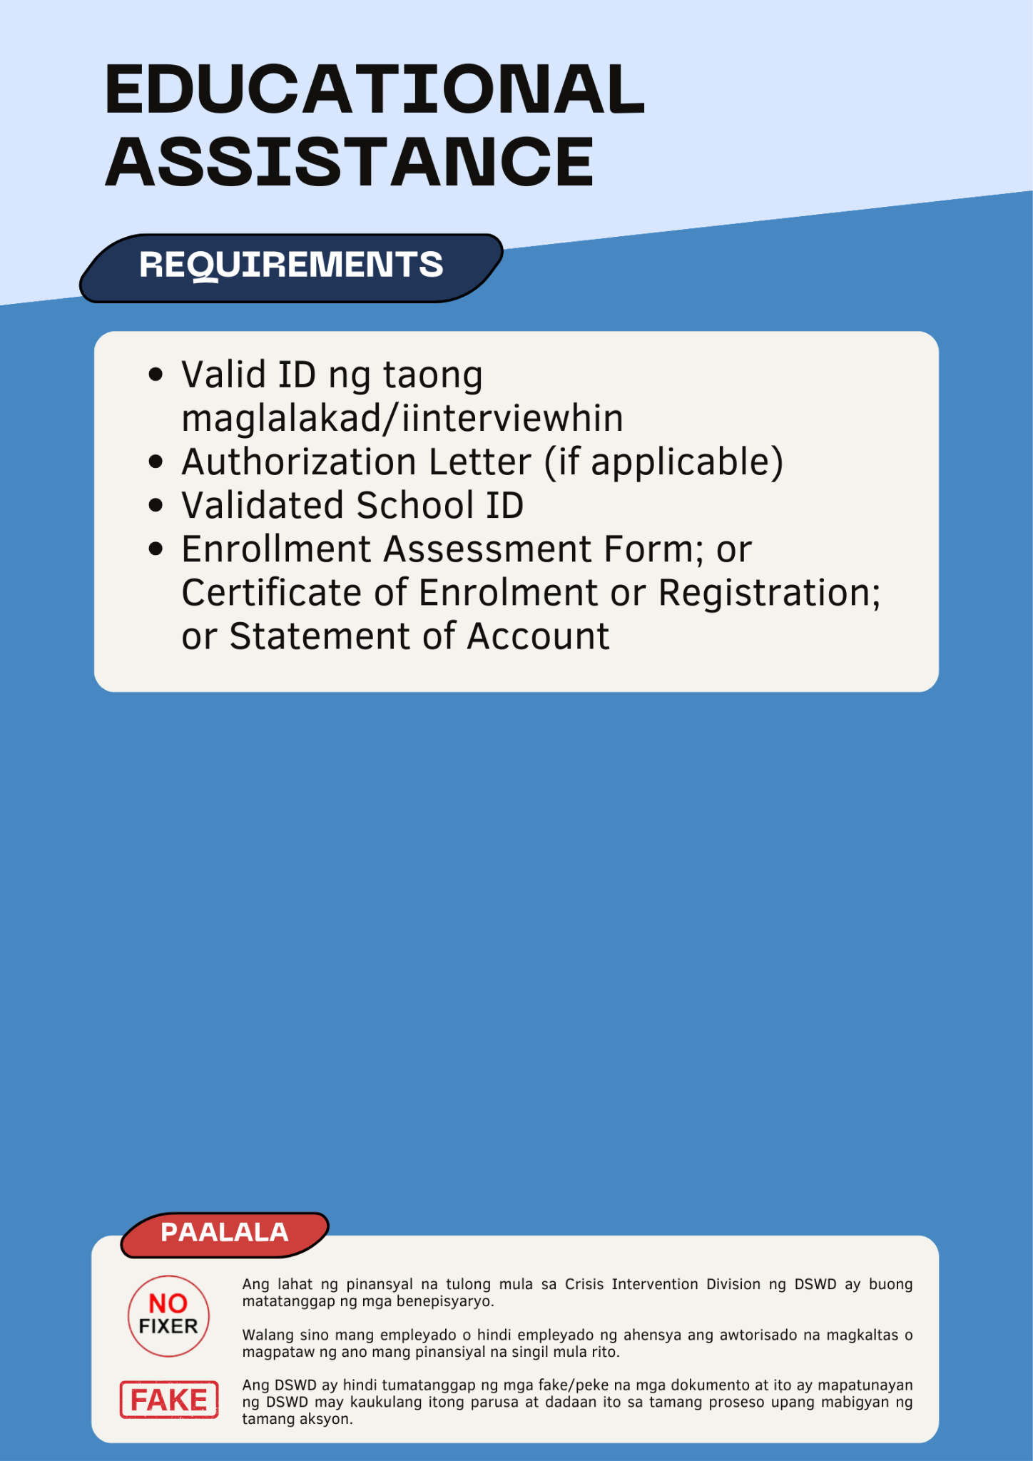

Medical Assistance
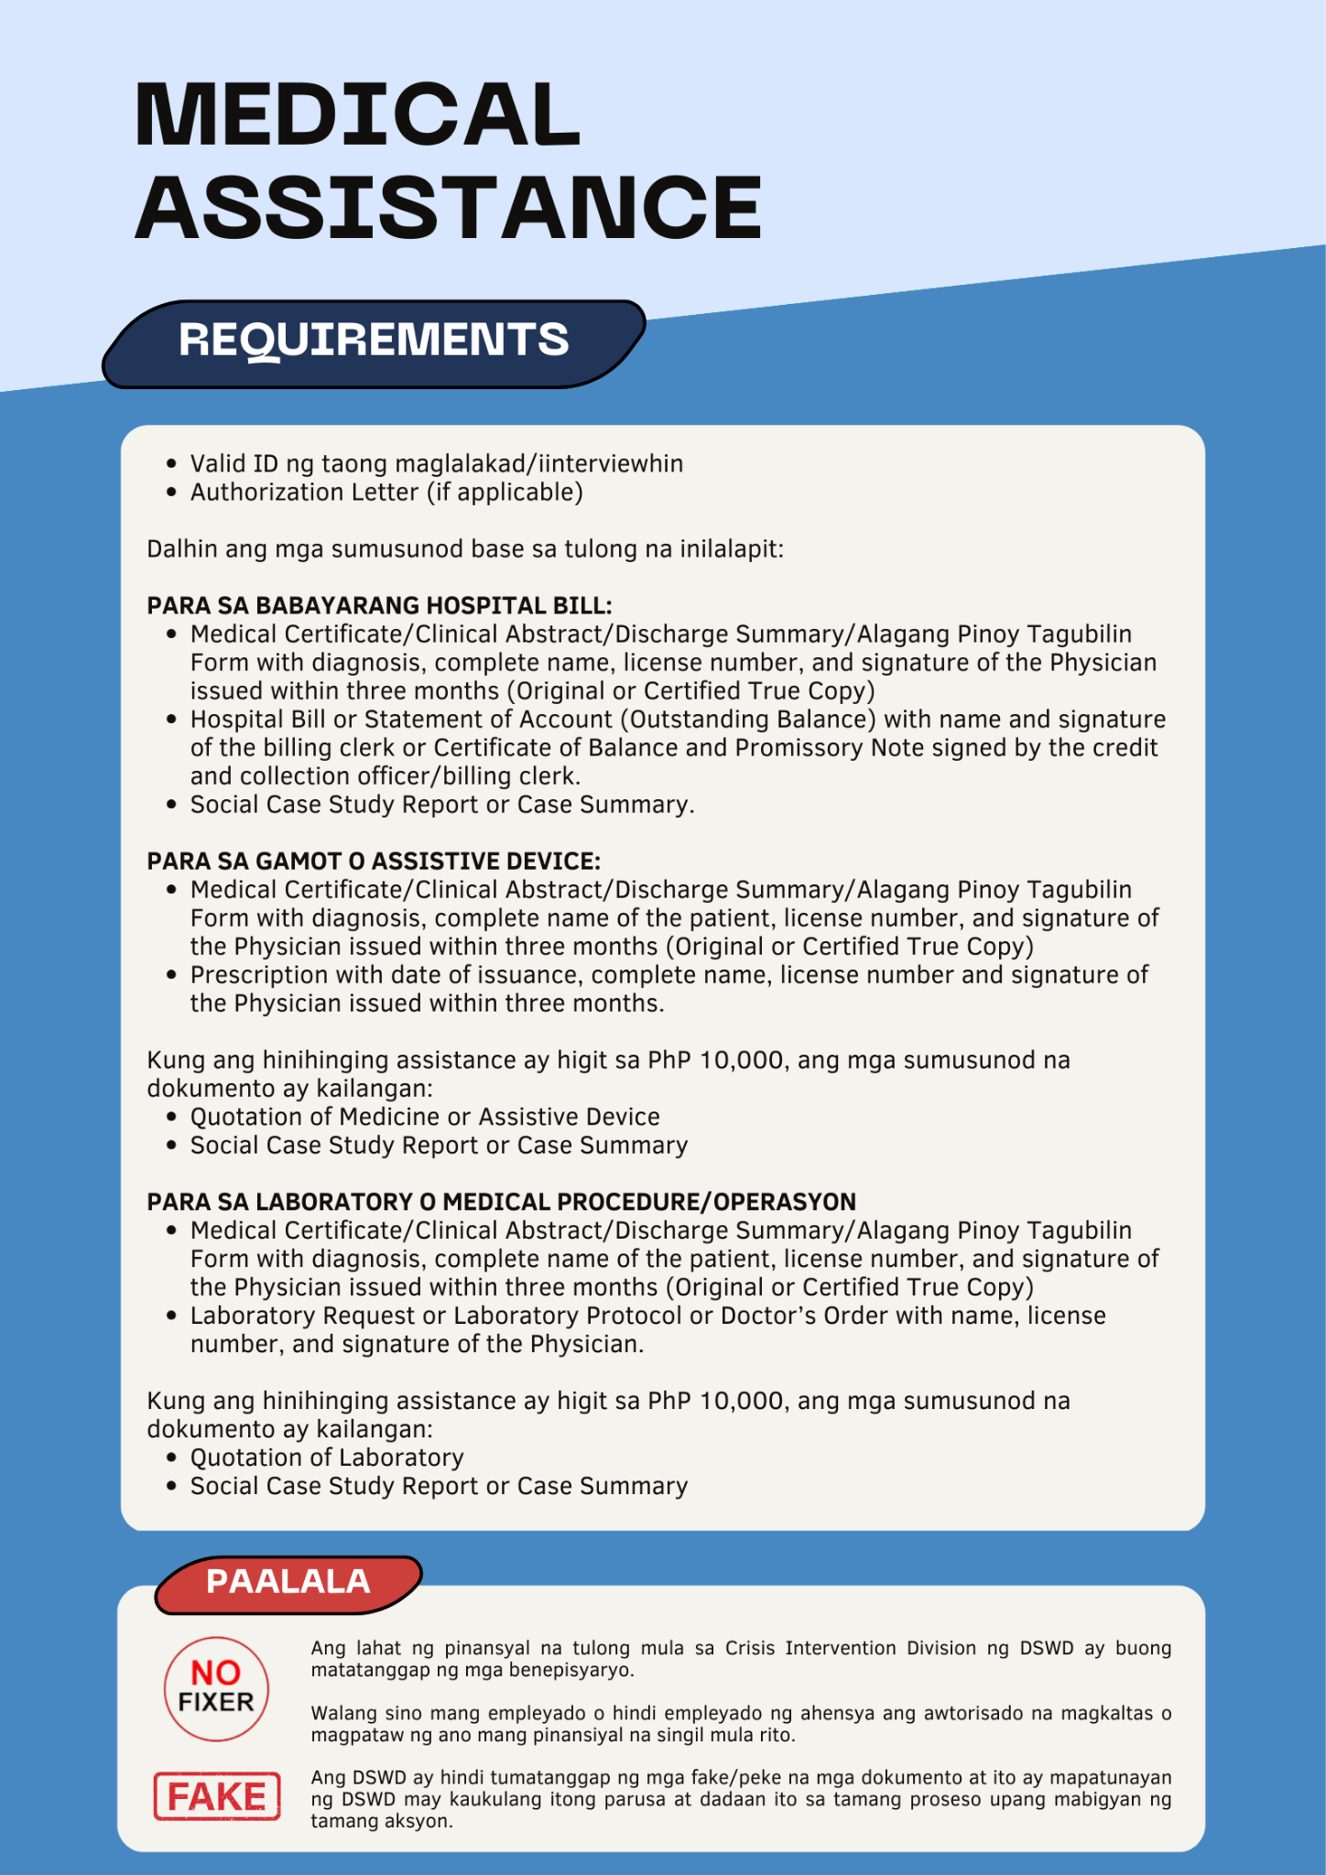

Burial Assistance
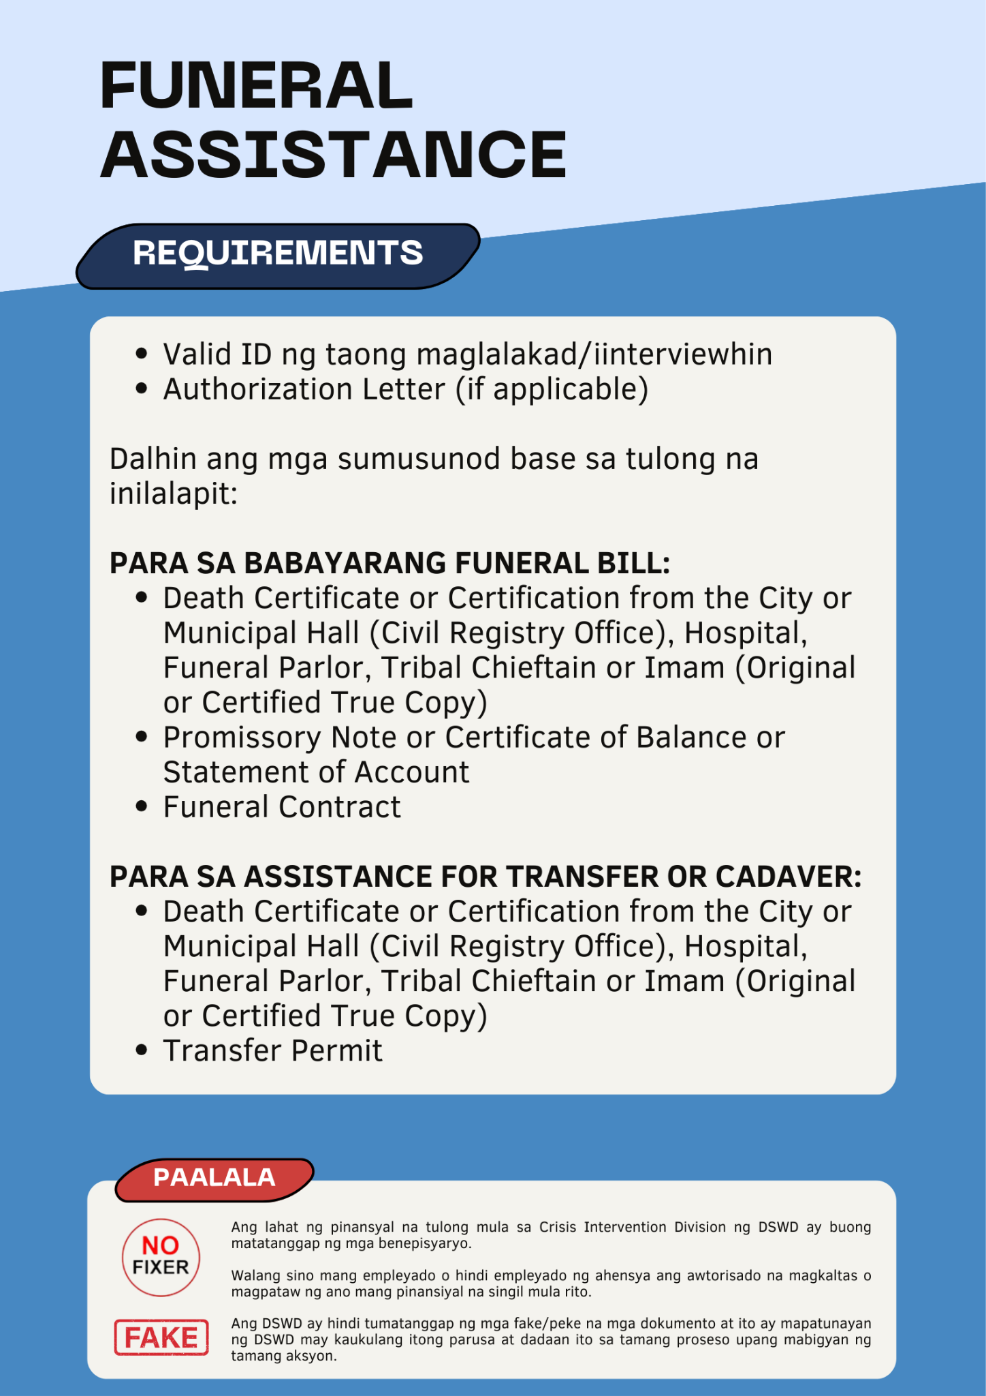

Contact Us

